Lab 6 Submission

Docker Container
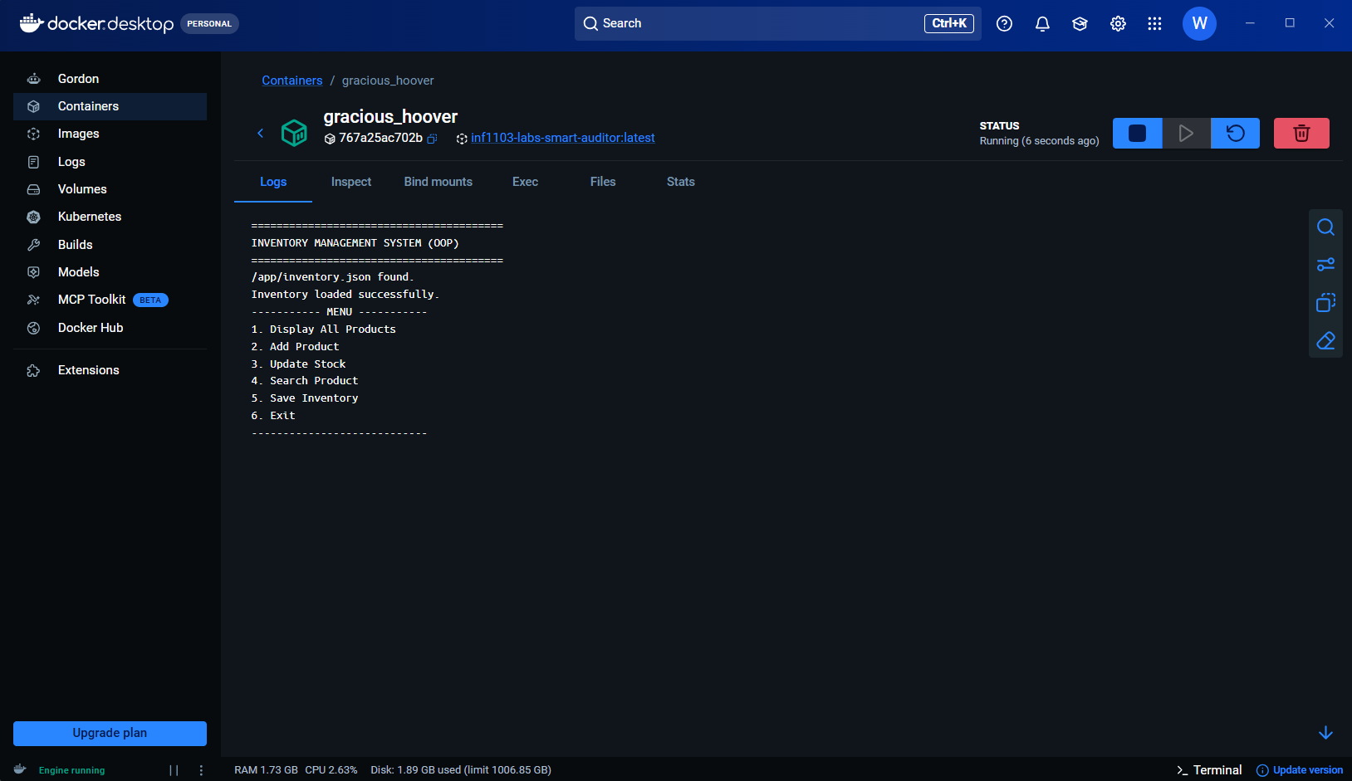

Accepting input & producing expected results


